Experiment-15

Aim
To detect corners in an image using the Harris Corner Detection method in Python and OpenCV.

Procedure
- Import the OpenCV and NumPy libraries.
- Read the input image using cv2.imread().
- Convert the color image into a grayscale image using cv2.cvtColor().
- Convert the grayscale image to float32.
- Apply Harris Corner Detection using cv2.cornerHarris().
- Highlight the detected corners in red.
- Display the output image.

Code
import cv2import numpy as np
img = cv2.imread("image.jpg")
gray = cv2.cvtColor(img, cv2.COLOR_BGR2GRAY)gray = np.float32(gray)
corners = cv2.cornerHarris(gray, 2, 3, 0.04)
img[corners > 0.01 * corners.max()] = [0, 0, 255]
cv2.imshow("Harris Corner Detection", img)
cv2.waitKey(0)cv2.destroyAllWindows()

Sample Input
An image named image.jpg containing objects, edges, or textured regions.

Sample Output
The original image with detected corner points highlighted in red.
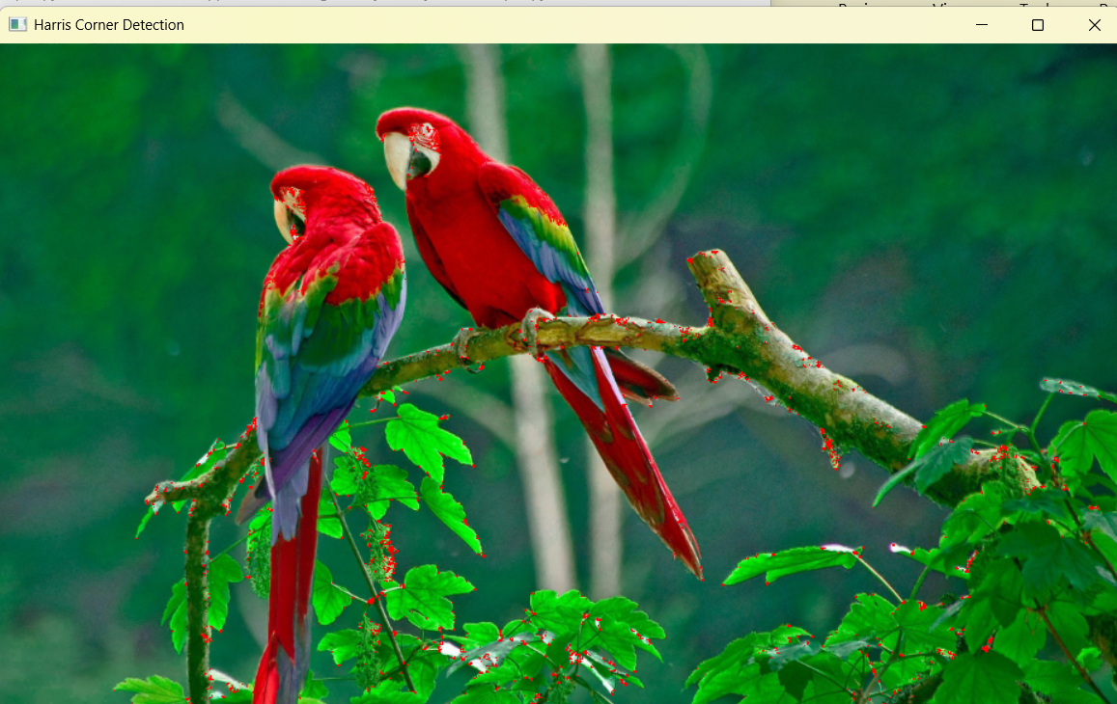

Result
Thus, Harris Corner Detection was successfully performed to identify and highlight corners in the input image using Python and OpenCV.

